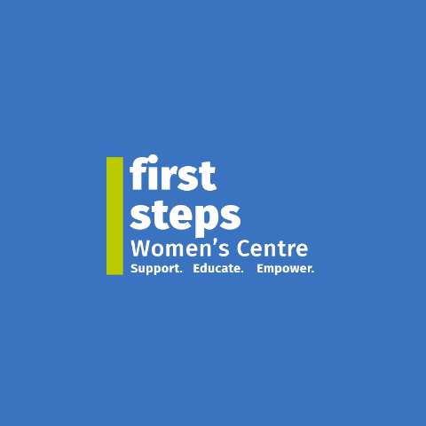





"Unity in Diversity: Empowering Ethnic and Minority Communities in Mid Ulster"
PEACEPLUS Minority Communities Project

Tender for PR Work January 2026-September 2028
Background Information
First Steps Women’s Centre, Dungannon, to lead on new drive to boost social cohesion and inclusion across Mid Ulster
Mid Ulster is set to benefit from a major new programme aimed at building intercultural understanding, inclusion, and community resilience. Led by the First Steps Women’s Centre (FSWC) in Dungannon, the three-year initiative across the Mid Ulster District Council area will deliver a range of diversity-based projects in schools, businesses, and community organisations.
Known as The Unity in Diversity: Empowering Ethnic and Minority Communities Project, it is part of Mid Ulster District Council’s co-designed €5.2M Local Community PEACEPLUS Action Plan. The Action Plan and new FSWC-led project are supported by PEACEPLUS, a programme managed by the Special EU Programmes Body (SEUPB).
Residents in the Mid Ulster area can look forward to a wide range of activities, including cultural celebrations, accredited ESOL English classes for women, Human Library and storytelling events and some school-based activities.
These will be planned with guidance and assistance from a co-design group made up of a number of nationalities.
As part of The Unity in Diversity Project, First Steps Women’s Centre (FSWC) is seeking to appoint a Public Relations Agent to work alongside FSWC to assist in delivering a Mid Ulster wide Diversity Campaign.
Budget is in the range of £40k-£49k
The programme will seek to support minority communities through:

- Delivery of a diversity campaign across the Mid Ulster District- to create awareness and increase greater respect for diversity across all our communities of Mid Ulster based on the model of sanctuary of being a welcoming and safe place to live.

- Delivery of events, activities and training- co designed with minority communities, to build capacity, awareness, knowledge and understanding of different cultures and traditions.

- A total of 500 people will be engaged over a 3-year period.

Delivery of a diversity campaign

This campaign will be delivered across the Mid Ulster District to create awareness and increase greater respect for diversity across all our communities of Mid Ulster based on the model of sanctuary of being a welcoming and safe place to live.

It will deliver 3 positive communication campaigns (1 each year of the 3-year programme) across the main towns in Mid Ulster District and online.

Target audience- all residents of Mid Ulster District.

The campaign will:

- Promote positive communication for respect and diversity with profile in places such as papers, bus shelters etc.
- Have a social media aspect to the campaign
- Online diversity materials / campaign that for a range of audiences e.g. primary and post primary schools, youth groups, community and voluntary sector etc. Through audience engagement identify any barriers to engagement and participation, including access to wider communities alongside groups.
- Promotional items campaign that has targeted messaging.
- Engage with minority community/ minority community support agencies for advisory and to ensure content.

Key messaging will include – only examples to be considered and developed, to be agreed with Council:
- Anti-hate
- Inclusion and inclusive communities
- Dispelling myths
- Welcoming and safe places etc.
- Welcoming diversity and difference
- Belonging

The application should be broken down into 3 specific years:
- January 2026-December 2026,
- January 2027-December 2027
- January 2028 to September 2028
As part of this Tender Application:
FSWC seeks an outline plan of key themes to be incorporated into the PR Campaign.
An outline cost for the PR campaign
An outline of the number of hours and cost per month providing PR for the programme.
Costs: Proposals should include the total daily rate (based on 7 hours per day), including VAT.
Total budget of £40,000-£49,000
Selection Criteria
Proposals will be selected on their ability to demonstrate appropriate knowledge, skills and capability to develop and deliver on a PR, communications and marketing plan and offer value for money to FSWC. They should highlight the agency/consultant’s suitability to fulfil the brief using examples of previous work carried out.

Scoring and Assessment Criteria
Pass/Fail Criteria
● The ability to deliver in the timeframe outlined
● That the consultant/agency will be contracted on a self-employed basis
Criteria | Score
Understanding of the project | 15%
Skills, knowledge and capability to deliver on this project, using examples of previous similar projects managed. These should include details of previous outcomes. | 50%
Approach and Delivery - Location - Management - Access to wider agency skills - values | 10%
Value for money | 25%

Tender Submission and Appointment Process
Please ensure that you provide information on each criteria area in a clear and concise manner to ensure that this can be reviewed and scored in line with the scoring matrix shown above.
1. Pass/Fail criteria
2. Understanding of the Project and the Brief
3. Skills, Knowledge and Capability
4. Approach and Delivery
5. Costs (should include VAT)
Applications should be submitted via email to fswc.tenders@gmail.com on or before Friday 5th December at 12.00 noon.
Tenders received after the closing date will not be considered.
The successful consultant/agency will be contacted in writing at the end of the process. It is hoped to complete this process by Monday 8th December 2025.
Further Information
Contact: Michael McGoldrick, Chief Executive Officer, 028 87727648
Email: fswc.michael@gmail.com

